**SciFest@ColaisteIosagain**

On Wednesday December 11th, over 100 transition year students gathered in the school PE hall to present their entries to this years SciFest@School competition. Great effort was made over the last number of weeks in preparing projects demonstrating creativity, innovation as well as substantial knowledge and application of the scientific method.

We were delighted to be joined on the day by Alan Dunne SciFest School Liaison Officer, Dean Hodge STEM Educational Officer with Offaly County Council, Anna Ridgeway Past pupil and Trinity PhD student of Ocular Genetics as well as Sinead Tuohy, Education Officer with the NCCA. Our visitors together with Eimear Foran, teacher Colaiste Iosagain, served as our judging panel for the day.

The standard of work presented was very high making it a difficult task for the judges. Prior to the award ceremony, Anna kindly spoke to the students together with those parents in attendance about her STEM career to date and of the exciting advances in gene therapy being made in relation to eye health. This inspiring input helped motivate our students toward achieving their potential in the STEM field.

The winners on the day were:

1st Place Overall; “How does music effect weightlifting performance?” by Adam O’Dea, Dominykas Mockus and James Kinsella.

2nd Place Overall; “Does music impact memory?” by Shanzay Soomro and Katie Slevin

Spirit of Colaiste Iosagain award; “The effect of MDMA” by Rory O’Donnell and Vinny O’Brien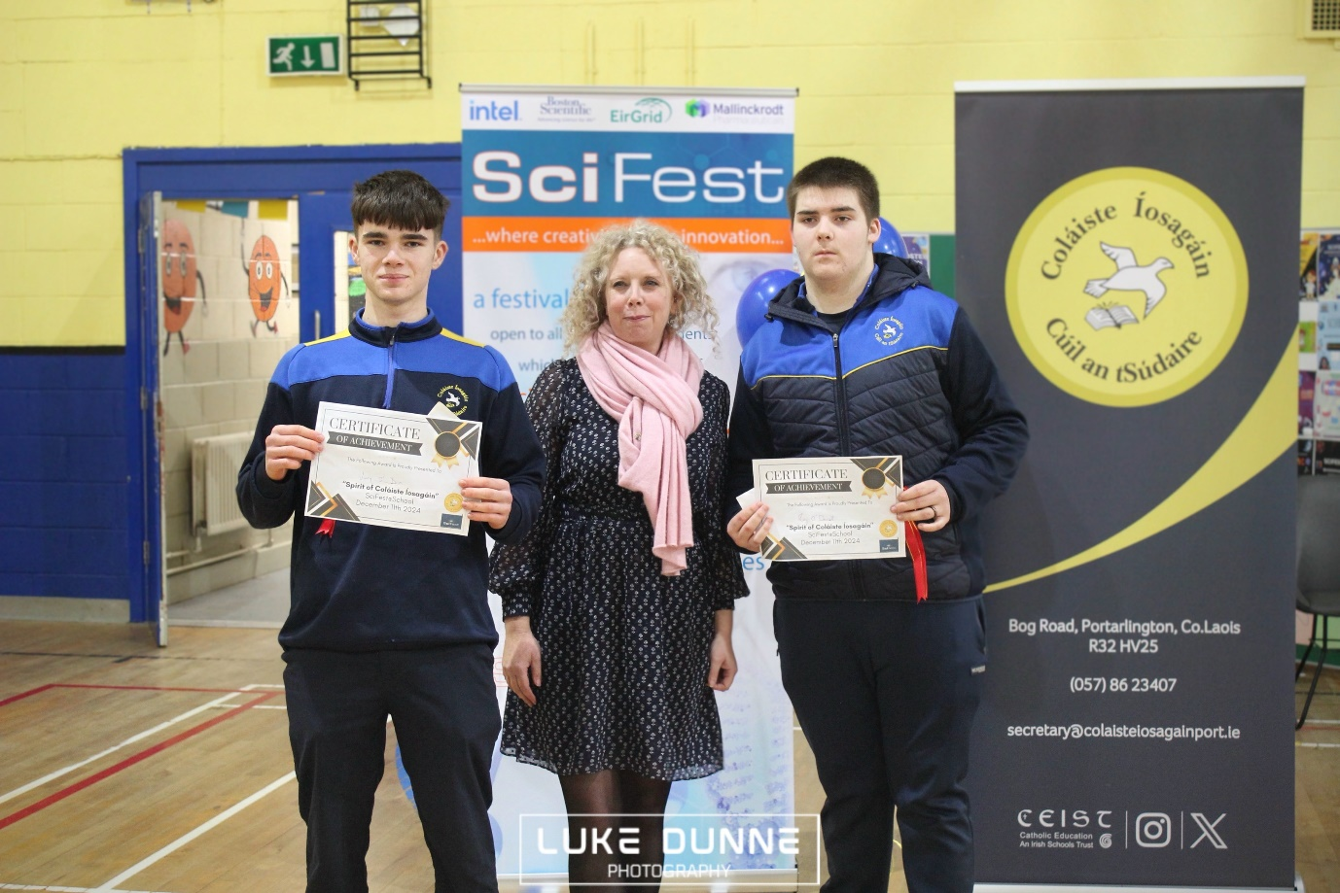

SciFest award; “Does word association help memory” by Nina Hayes, Hannah Connell and Keelin Weston

Best Display award; “Smart phone usage Senior Vs. Junior students” by Tadhg Flynn, Paula Kurmauskaite and Katelyn Higgins

Our judging panel together with Mairead Bergin, Science teacher Colaiste Iosagain.

Well done to all involved and special thanks to both our judges and teachers Ms. Delaney, Mr. McGlynn, Mr. Brennan, Mr. O’Donnell, Ms. Cleary, Mr. Cotter, Ms. Bergin and TY co-ordinator Ms. Holloway.

