**Presentation Day 2024**

Every November, Presentation Day is celebrated around the world to honour the Irish woman and foundress of the Presentation Sisters, Venerable Nano Nagle.

The prayer focuses on the now famous Nano Nagle Icon. The Presentation Sisters have provided a very helpful booklet that assists those seeking to pray with this beautiful icon. For a soft copy of this booklet see: <file:///C:/Users/kateliffey/Downloads/Exploring%20the%20Nano%20Nagle%20Icon%20booklet.pdf>) Much of the material for this prayer service is drawn from this booklet.

In this booklet we read that, “An icon is a religious work of art” and that “an icon is a visual doorway leading us and helping us to focus on God. It enables us to reflect silently and patiently.”

The Icon of Nano Nagle was ‘written’ by Irish artist Desmond Kyne in the 1970s. Icons are described as being written rather than painted. The Icon portrays Nano Nagle immersed both in the mystery of God and amongst the people of 18th century Ireland.

The material presented here for Presentation Day 2024 can also be adapted for use for relevant parts of a Presentation Day Mass and can also be used as a standalone prayer service for groups or a whole school assembly. We know that many of our CEIST schools in the Presentation tradition, have a Nano Nagle Icon in their school. This can of course be referred to as you pray this prayer service with your students. The images used here can be the basis of a PowerPoint combining images from your own school, including your school crest.

This prayer service seeks to bring the Icon into this year’s prayer time in a way that invites engagement with specific panels of the Icon at specific moments of the prayer. The richness of the Icon will not be captured here and schools themselves have found incredibly creative ways of encouraging students to engage with the image of the Lantern, the story of Nano and the Icon itself.

The suggested hymns are presented here as illustrative; your music department working with your RE teachers will be best placed to choose hymns and songs most suitable for your own students and school context. Your RE team will also be best placed to adapt this material to suit your school’s history and traditions.

**Opening Hymn**: Shine Jesus Shine, Grahan Kendrick.

**Principal:** We welcome you all to our prayer service today to mark Presentation Day. Every year, this very important day is celebrated here in ______________ (school’s name). *(A short piece on the school’s founding and history can be shared here*). As we begin our prayer together, we pause now in silence with the immense wealth of our history behind us, giving us courage as a school community and as individuals to go forward in faith, hope and love.

We begin our prayer by taking a moment to look at the wonderful icon of Nano Nagle that we see here. We take a moment in silence to notice the colours, the patterns, the images, the light, the shapes. We allow our eyes to be drawn to the figure of Nano at the centre as _________________ , _____________________and ___________________ will now read this short passage about Nano Nagle. Who was Nano Nagle and why is she so important not just to us in __________________________ but to so many others in Ireland and around the world?

(Note this material is adapted from: <https://nanonagleplace.ie/the-story-of-nano-nagle/> )

**Reader 1:**

If Nano Nagle were alive today, she would be the kind of person to win a Nobel Prize. Before her death in 1784, Nano had opened seven schools for poor children across Cork city, founded a house of refuge for poor women, and most notably, founded the Presentation Order, who continue her education and social inclusion work today. Born to a wealthy Catholic family in 1718, Honora Nagle was given the pet name Nano by her father. The Nagle family home at Ballygriffin, near Mallow, was on the banks of the river Blackwater.

As a child Nano experienced a lovely childhood with her younger siblings. However, because of the Penal Laws meant that education for Catholics was not available in Ireland, Nano’s family had Nano educated in France. Afterward she went to Paris to live with her relations.

A series of life changing events inspired Nano to devote her life to the service of the poor. When Nano’s father died and she and her sister Ann returned to Dublin to be with their mother, Nano began visiting poor families with Ann. Ann died suddenly, quickly followed by her mother. Nano decided she would devote her life to helping the poor.

**Reader 2:**

Since under the Penal Laws, operating a Catholic School could result in three months imprisonment, Nano had to work in secret. She began by opening a school for young girls in the early c. 1750s. This girls’ school focussed on reading, writing, Catechism (Catholic religious instruction) and needlework.

Within ten years demand for the education which Nano provided was such that she was operating seven schools across the city of Cork, teaching both boys and girls. By day she visited each of her schools, and by night she visited the poor of the Cork city. This was dark and dangerous work. Nano travelled by the light of the lantern she carried, and across the city of Cork she became known as ‘Miss. Nagle,  ‘the Lady of the Lantern’.

**Reader 3:**

Nano founded her own religious order ‘The Institute of Charitable Instruction of the Sacred Heart of Jesus’ in 1775. She and three followers promised poverty, chastity and obedience to God until death. They continued to teach and care for the poverty stricken where they lived. For five years, the small cottage near Nano’s first school, on modern day Douglas Street, just south of Cork city centre, was their first convent. Nano then built a small convent on the same street, where sisters from the order are again living today (albeit in a newer building on the site).

Nano’s long days and constant walking across the city took a toll on her health. She died at the age of 66 in 1784. Her order, the Presentation Sisters, have continued her mission across the world and into the present day. In 2005, she was voted Ireland’s Greatest Woman ever in a poll of 22,000 people run by Radio 1 in Ireland.

**Principal:** We listen now to our Opening Prayer read to us by _________________________

**Reader 1:** Opening Prayer

Loving Father, Nano Nagle was an amazing woman. You call on each of us to be amazing as well. But not for our own sake, not to be the most popular or the cleverest, or the sportiest but to be people who look after other people. As we contemplate the icon of Nano Nagle, we also take a moment to reflect on the icon that is each of us. None of us is perfect but we can do great things with our lives. With your love for us, and our faith in you, great things can happen in our lives. Bless us today as we reflect on what the story of Nano Nagle has to teach us about ourselves and our world.

**Principal:** Symbols will now be presented and placed in our sacred space. These symbols represent Nano’s life story and how that story can be reflected in our story.

**Reader 3:**

Our first symbol is of a schoolbook. It is brought to our sacred space by ________________. Nano opened her first school in Cork when it was illegal to do so. As we celebrate Nano today, may we take the time to celebrate the gift of our education. In the Icon, in the top left-hand corner we see Nano teaching the poor children of Cork. You will notice that many of the children aren’t wearing shoes. Poverty was a huge issue in Ireland at that time. Education gave these children and their families hope. We also see her with a book; the book has empty pages. This is because Nano taught from her heart. We thank God today for the ways in which our teachers teach not only their subjects but also form relationships with us that nurture us and support us. We thank them for their kindness, for their sense of humour, for the ways they show they care for us in how they treat us.

Our second symbol is of a lantern. It is brought to our sacred space by ______________. Although Nano lived in very dark and troubled times, the Icon is full of light and brightness. The Icon is full of hope. The Icon here shows us Nano’s care for the sick, the lonely and the old. Nano carrying a lantern through the dark lanes and alleyways would have been a familiar sight in Cork. It was said there was not a single house in the city that she did not know or did not visit. As we reflect today on Nano, let’s also reflect on how we shine light in the lives of others; by going out of our way to help a friend who is struggling, by making sure to include people who feel isolated or lonely, by fundraising for good causes, by being a voice that calls out to others to protect our planet, by helping out at home when we’re needed and just in general by being our most awesome selves. We can be icons of hope in our world today.

Our third symbol is of a prayer book and a bible. These are brought to our sacred space by __________________ and _________________________.

This part of the icon shows Nano in prayer. Nano could only do what she did because of her faith. The mystery of God’s love is what drew Nano to those who were poor and suffering. She saw them in a new light – as children loved by God. This experience of God’s love compelled her to reach out to those who did not experience God’s love and light. We take a moment to reflect on our own faith in God. We pause to dwell deeply on God’s love for each and every one of us. We take a moment in complete stillness and quiet to acknowledge the ways we are called into relationship with God who is Love.

We now present a symbol of a compass. It is brought to our altar by ___________________. Compasses give us direction. For Nano the heart of her compass was her relationship with God, and in many ways the needle of the compass was her devotion to Mary.

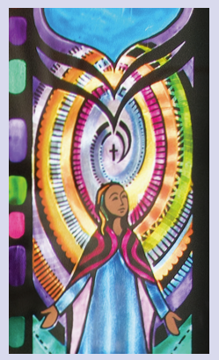

The Presentation of Our Lady was the favourite title under which Nano prayed to the Mother of God. Today the 21st November is the Feast of the Presentation,

At the Presentation Mary was offered by her parents to God and totally surrendered her life to God. Nano surrendered her life to God. With Mary as her model, Nano became a woman of compassion, contemplation, courage, creativity, and energy for her faith. She challenged her people’s brutal oppression, risking a lot to help those most in need.

During our prayer today we turn to Mary as Nano did and pray for the courage these two women showed through out their lives. May we also be unafraid to take risks to do what is right and just.

**Principal:** Our final symbol is the whole community gathered here. Though we are many, we our united by our belonging to this school. Your friends are here; many of you have siblings who are here; some of you have parents who came here. This is a place where we pray for you and with you. You are an essential part of our Presentation family; a family that stretches around the world

As we reflect further on the Icon of Nano Nagle, we pray together in Song

Hymn: Christ be our Lord, B. Farrell

**Principal:** We listen now to the word of God

**Reader 4:**

A reading from St Paul’s First Letter to the Corinthians.

If I speak in the tongues of people or of angels, but do not have love, I am only a resounding gong or a clanging cymbal. If I have the gift of prophecy and can understand all mysteries and all knowledge, and if I have a faith that can move mountains, but do not have love, I am nothing. If I give all I possess to the poor and give over my body to hardship that I may boast, but do not have love, I gain nothing.

And now these three remain: faith, hope and love. But the greatest of these is love.

The Word of the Lord.

**Thanks be to God.**

**Responsorial Psalm:** You are Mine, David Haas

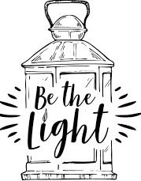

**Hymn:** Faith, hope and Love (D. Hass)

**Principal’s words (optional):**

The images we’ve seen today can be summarised with three simple words; Faith, Hope and Love. And they’re all interconnected in the Icon in front of us. They’re there in Nano’s prayer but they’re also there in the way she cared for people. What made Nano special is that she really lived all three together. She could have looked at the situation of her world at the time, thrown her arms up and just given up. She could have taken a much easier path. But in her faith and in her love she found hope. She also found faith, hope and love in her family, among her friends and in her community.

In our school, we try to do the same. We say to you as students in our school, you don’t have to just through your arms up and give up. Yes, there’s lots that is difficult in life. But you aren’t on your own. There’s lots going on in our world that’s really hard; we only have to think of climate change and the confict that’s happening in the middle East. But we believe each of us can make a difference in our own lives to make the world a better place, just as Nano did.

(You might give some examples here from your own school of faith, hope and love in action. Feel free to add images to your PowerPoint that express faith, hope and love in your school).

In preparing for today’s service, this quotation from Richard Attenborough came to mind,

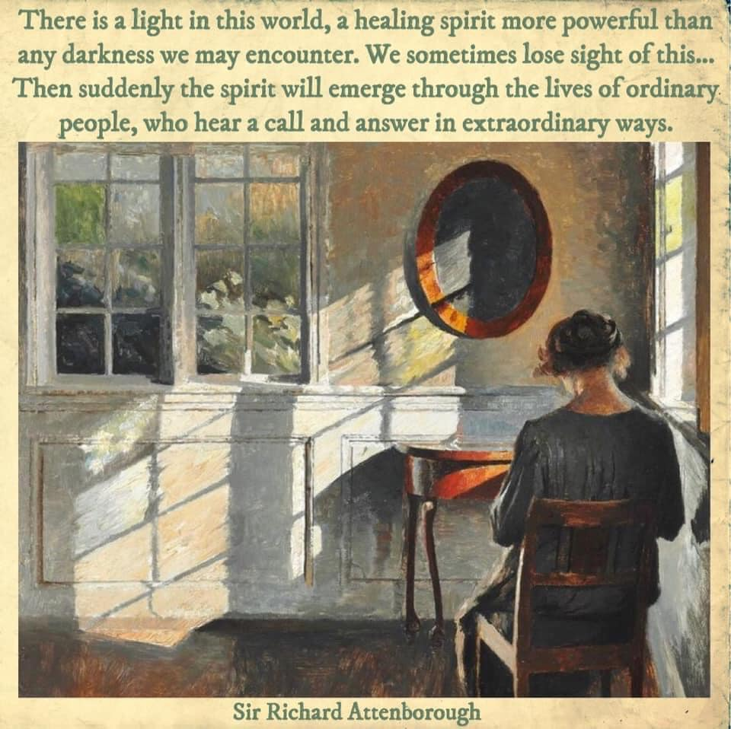

When we reflect on these words, we think of all the ways we are a light to other people and all the ways we can in our school be a light to the world. Of all the images presented to us today, perhaps it is the image of Nano with her lantern that is the most important one of all.

**Principal:** We pray now together…. And our response is ….. **Lord graciously hear us.**

**Readers 5, 6, 7**

Faith:

Faith: In our school and in our world, we pray we will all have the courage to take time to be silent in ourselves and allow the God who is love speak to us words of peace, consolation and joy. And may these words, as they did for Nano inspire us to act for the good of others. Lord hear us. **Lord graciously hear us.**

Hope:

Hope: Sometimes life is hard. We pray that we’ll have Nano’s courage to see where hope can bring us. Hope is an active thing. Lord help us to shine the light of hope in the dark places in our world. We pray at this time especially for peace in our world. We pray also for the courage to act with hope to protect our planet. Lord hear us. **Lord graciously hear us.**

Love:

Love: We pray in gratitude for the love we experience in our families, in our school and among our friends. Love is what makes sense of everything in life. We pray at this time in a special way for those who are sick or lonely. Like Nano may we have the courage to reach out in love to those who most need us at this time. Lord hear us. **Lord graciously hear us.**

**Principal:**

(Final words and words of thanks)

**Closing hymn:** City of God (D. Schutte)